**COGNIZANT - DIGITALNURTURE4.0**

**DEEPSKILLING JAVA FSE**

**NAME: BHAVANA REDDY M  
SUPERSET ID: 6384852**

**WEEK 01: DESIGN PATTERNS AND PRINCIPLES**

**EXERCISE 01: IMPLEMENTING THE SINGLETON PATTERN**

SingletonPatternExample/

└── singleton/

├── Logger.java

└── LoggerTest.java

**//Logger.java**

package singleton;

public class Logger {

private Logger() {

System.out.println("Logger initialized.");

}

private static class LoggerHelper {

private static final Logger INSTANCE = new Logger();

}

public static Logger getInstance() {

return LoggerHelper.INSTANCE;

}

public void log(String message) {

System.out.println("[LOG] " + message);

}

}

**//LoggerTest.java**

package singleton;

public class LoggerTest {

public static void main(String[] args) {

Logger logger1 = Logger.getInstance();

logger1.log("First message");

Logger logger2 = Logger.getInstance();

logger2.log("Second message");

if (logger1 == logger2) {

System.out.println("Both logger instances are the same (Singleton works).");

} else {

System.out.println("Different instances (Singleton failed).");

}

}

}

**//Output**

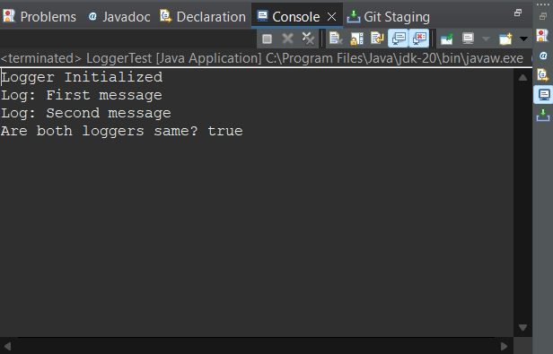

**EXERCISE 02: IMPLEMENTING THE FACTORY METHOD PATTERN**

FactoryMethodPatternExample/

└── documents/

├── Document.java

├── WordDocument.java

├── PdfDocument.java

├── ExcelDocument.java

├── DocumentFactory.java

├── WordDocumentFactory.java

├── PdfDocumentFactory.java

├── ExcelDocumentFactory.java

└── DocumentFactoryTest.java

**//Document.java**

package documents;

public interface Document {

void open();

}

**//WordDocument.java**

package documents;

public class WordDocument implements Document {

public void open() {

System.out.println("Opening a Word document.");

}

}

**//PdfDocument.java**

package documents;

public class PdfDocument implements Document {

public void open() {

System.out.println("Opening a PDF document.");

}

}

**//ExcelDocument.java**

package documents;

public class ExcelDocument implements Document {

public void open() {

System.out.println("Opening an Excel document.");

}

}

**//DocumentFactory.java**

package documents;

public abstract class DocumentFactory {

public abstract Document createDocument();

}

**//WordDocumentFactory.java**

package documents;

public class WordDocumentFactory extends DocumentFactory {

public Document createDocument() {

return new WordDocument();

}

}

**//PdfDocumentFactory.java**

package documents;

public class PdfDocumentFactory extends DocumentFactory {

public Document createDocument() {

return new PdfDocument();

}

}

**//ExcelDocumentFactory.java**

package documents;

public class ExcelDocumentFactory extends DocumentFactory {

public Document createDocument() {

return new ExcelDocument();

}

}

**//DocumentFactoryTest.java**

package documents;

public class DocumentFactoryTest {

public static void main(String[] args) {

DocumentFactory wordFactory = new WordDocumentFactory();

Document word = wordFactory.createDocument();

word.open();

DocumentFactory pdfFactory = new PdfDocumentFactory();

Document pdf = pdfFactory.createDocument();

pdf.open();

DocumentFactory excelFactory = new ExcelDocumentFactory();

Document excel = excelFactory.createDocument();

excel.open();

}

}

**//Output**

